on production

mkdir file_name

$ mysqldump -u rupesh.arbal -p --single-transaction DB_NAME TABLE_NAME | gzip > DB_NAME.TABLE_NAME.gz

$ mysqldump -u rupesh.arbal -p --single-transaction --routines --triggers --events --all-databases |gzip > DB_NAME.gz (IF YOU TAKE FULL BACKUP)

$ mysqldump -u rupesh.arbal -p --single-transaction --skip-triggers DB_NAME TABLE_NAME | gzip > DB_NAME.TABLE_NAME.gz (TO SKIP TRIGGER)

$ mysqldump -u rupesh.arbal -p --single-transaction DB_NAME TABLE_NAME | gzip > /destination_on_directory/DB_NAME.TABLE_NAME.gz (giving path where to backup done. )

-------------- (If restoration database has different name) -----------------
So, Dump without --database keyword. and Include the option --no-create-db
$ mysqldump -u username -p --no-create-db old_database_name > dump.sql

And restore it with the target database name.
$ mysql -u username -p target_database_name < dump.sql

(password:- sql :- Rup@sh!234)

chmod -R 777 *
chown mysql:mysql file_name

$ zcat file_name | tail -10f (it can show export activite completed or not)

on UAT

$ mkdir file_name
root$ chmod 777 file_name

------------------- For scp we use pull methode -----------------------
push method
$ scp /path/of/source/file_name user@server_IP:/path/to/destination/directory (standing on source server and server_IP=target ip and user name)

pull method
$ scp user@server_IP:/path/to/source/directory (standing on target server and server_IP=source ip and user name)

scp /dbdata/mysql/billing_workbench_13feb2023/billing_workbench.gz SA.Raju.Bakane@uatwhsdb01:/dbdata/mysql/billing_workbench_restore_13feb2023 (PUSH METHOD)
(password:- 2ra+a2AP {os password})

on UAT
chown mysql:mysql file_name

$ gunzip file_name

MYSQL> select count(*) from db_name.table_name; (on both side source & Target)

MYSQL> rename table identity to identity_15022023;
MYSQL> create table identity like identity_15022023;

### Restoration
$ mysql -u root -p DB_NAME < file_name
======================================================================

MYSQL> show table status like table_name\G; (Here we can see structure of that table)

MYSQL> show create table table_name\G ;

MYSQL> alter table identity_15022023 drop FOREIGN KEY FK_identity_authorities ; (remove FOREIGN key in a table identity_15022023=table_name, FK_identity_authorities=FOREIGN key link reference to the table/column )

MYSQL> SELECT * FROM INFORMATION_SCHEMA.TRIGGERS WHERE TRIGGER_SCHEMA='schema_name'\G (To see trigger in the database.)
SELECT * FROM INFORMATION_SCHEMA.ROUTINES WHERE ROUTINE_SCHEMA = 'your_database_name'; (To see procedures and functions in the database)

To prevent a table from being exported, use the following command:
$ mysqldump -u USER_NAME -p DB_NAME --ignore-table=DB_NAME.TABLE_NAME > file_name

mysql> create table new_table like existence_old_table ; (creating new table with same metadata)

mysql> insert into new_table select * from existence_old_table; (it can copy all data and transfer to new table)

-------------------------------- SCP Command ------------------------

Basic Syntax
$ scp [option] /path/of/source/file user@server-IP:/path/of/destination/directory

-C compresses the file
-P Use this option to specify the SSH port if the default SSH port is not set to 22.
-r recursively copies

$ scp nextcloud-21.0.1.zip bob@192.168.2.103:/home/bob (option-no nextcloud-21.0.1.zip=zip file name )

Push Mode :

scp filename user@remoteserver:/stage_software

scp file.txt oracle@192.168.56.10:/stage_software

scp -r DBA oracle@192.168.56.10:/stage_software (For directory use -r )

Pull Mode :

scp host_name@192.168.56.11:/stage_software/file.txt .
(Last . is for transfer current file) (stand on target and pull data and give all information at the source side) (host_name,host id, path all information give at source side )
===================================================

Sed command
If you want to import database to another database name.
(We can apply for specific table also)
$ mysqldump MYDATABASE > mydump.sql (Take first export backup)

(then use sed to replace the old database name with new one like this)
$ sed -i 's/FIND_TEXT/REPLACE_TEXT/' file.sql (syntax)
-i for --in-place[=SUFFIX]
-s for --separate

$ sed -i 's/MYDATABASE/MYNEWDATABASE/g' mydump.sql
Ex $ sed -i 's/coa_database/new_coa_database/g’ coadump.sql

To cross check old database name is not in dump file

$ cat mydump.sql | grep "MYDATABASE"

mysqladmin create MYNEWDATABASE

mysql MYNEWDATABASE < mydump.sql

mysql> source nfaappatc_prod.coa_approver_mapping_UAT_15dec22
mysql> source nfaappatc_prod.coa_details_UAT_15dec22

#### If you take full database backup and for restoration you want only single table restoration and don’t touch to other table
$ sed -n '/CREATE TABLE `your_table_name`/,/UNLOCK TABLES;/p' your_dump.sql > your_table.sql

This command extracts everything from the line containing CREATE TABLE your_table_name`` (inclusive) to the line containing UNLOCK TABLES; (exclusive) and saves it to a new file named your_table.sql.
=====================================================================
#### Restoration of single table from full database backup
Dump Script file typically begin with CREATE TABLE followed by the table name and end with a line like UNLOCK TABLES;
$ sed -n '/CREATE TABLE `your_table_name`/,/UNLOCK TABLES;/p' your_dump.sql > your_table.sql

This command extracts everything from the line containing CREATE TABLEyour_table_name`` (inclusive) to the line containing UNLOCK TABLES; (exclusive) and saves it to a new file named your_table.sql.

Or you can restore full database in duplicate database name. and after that you can take single table.

if you want add word/special character at the start of specified line

$ sed -i '81s/^/-- /' my_dump_file.sql
- ^/-- /: Inserts -- (two hyphens and a space) at the beginning of line 81, effectively commenting it out.

$ Backup MySQL Users and Privileges Table:
mysqldump -u your_username -p --no-data mysql > mysql_users_privileges_backup.sql or
mysqlpump -uroot -p[your password] --host=[your host] --exclude-databases=% --users --exclude-users=root,[other users to exclude] > mysqlusersandgrants.sql

Verify the Backup File:
less mysql_users_privileges_backup.sql

Restore Users and Privileges:
mysql -u your_username -p < mysql_users_privileges_backup.sql

$ Trigger backup and restoration.
If you want to take backup of trigger table and restore it you have take trigger backup separate and table data separate backup.
MYSQL> SELECT * FROM INFORMATION_SCHEMA.TRIGGERS WHERE TRIGGER_SCHEMA='schema_name'\G (To see trigger tables in particular database)
$ mysqldump -u your_username -p --databases database_name --no-data --no-create-info --triggers > database_name_bkp.sql
(before restoring to table you have to first remove old triggers other wise it show error or use below command)
$ mysqldump -u your_username -p --databases database_name --no-data --no-create-info --triggers --add-drop-trigger > database_name_bkp.sql
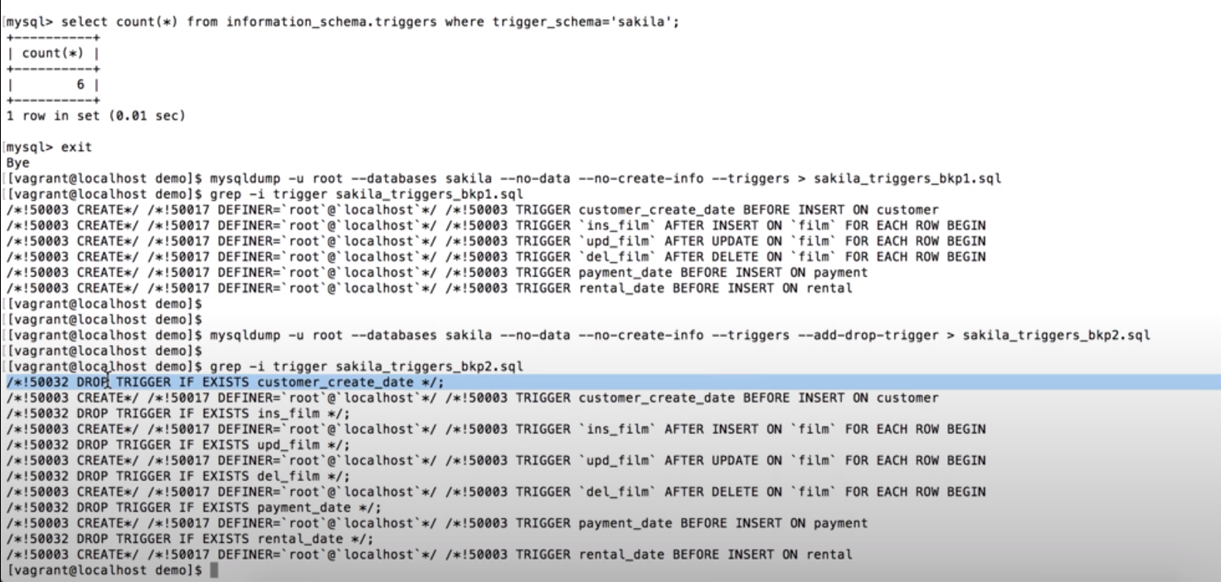
$ mysqldump -u USERNAME -p --routines --no-create-info --no-data --no-create-db --skip-opt lm_cia > outputfile.sql
(Taking backup of stored procedures and function) or
$ mysqldump -u USERNAME -p --routines DBName > outputfile.sql

===========================================================================
$$$$$$$$$ Point in time Recovery
scenario :- if you take backup still monday 12 pm and your database drop at tuesday 1 pm then we restore database still monday 12 pm by useing backup and
in between monday 12 pm to tuesday 1 pm data recover by using binary log.
We want data before drop database statment.

solution steps:-
1) cat backup.sql | grep " CHANGE MASTER "
----- change master to master_log_file= ‘binlog.0012” , master_log_pos= 254215319;
(backup.sql is last backup, and gives last position no. which make first position no. in recovery. and master_log_file show binlog file and master_log_pos show last log position.)

2) we check is that statment present in that bin log file or not
mysqlbinlog -v binlog.0012 | grep -i "drop database prod" (prod=database name)

or pager grep -A 1 -B 2 'PROD' | grep -B 4 droop

show binlog events in 'binlog.0012';
(it set pager to check statment drop & show statements and here also see position no. of that drop statement)

or mysqlbinlog -v /var/lib/mysql/binlog.0012 > master.txt
(master.txt making this file to store all the data from that bin log)
grep -B 7 -A 1 "drop database" master.txt (it show statement then chose position no. "at no." just above drop database statement)

------- at step 1 we get start position and step 2 we get end poisition

3) restore
$ mysqlbinlog --start poisition xxxxxx --end poisition xxxxxx /var/lib/mysql/binlog.0012 | mysql (at last mysql restore directly to their database and folder)

or mysqlbinlog --start poisition xxxxxx --end poisition xxxxxx /var/lib/mysql/binlog.0012 > make_one_dump_file.txt
mysql prod < make_one_dump_file.txt
soure make_one_dump_file.txt

$$$$$ if you have more then one binlog file then
ex binlog.0012
binlog.0013
binlog.0014
binlog.0015
binlog.0016
(at first binlog their is start position and at last binlog is end poisition or before drop database statement)

mysqlbinlog --start poisition xxxxxx /var/lib/mysql/binlog.0012 | mysql
mysqlbinlog /var/lib/mysql/binlog.0013 /var/lib/mysql/binlog.0014 /var/lib/mysql/binlog.0015 | mysql
mysqlbinlog --stop poisition xxxxxx /var/lib/mysql/binlog.0016 | mysql

To take an incremental backup in MySQL, you can follow these step-by-step instructions:
1)Set some MySQL configuration file (my.cnf or mysqld.cnf):
- Set innodb_log_file_size to a reasonable size (e.g., 1GB) to ensure sufficient space for incremental changes.
- Set innodb_file_per_table=ON to enable per-table tablespaces.
- Enable the binary log by setting log_bin=ON. This allows the server to record changes to the database.
2)Create a Full Backup by using
1) mysqldump
$ mysqldump --user=<username> --password=<password> --all-databases > full_backup.sql
2) Percona XtraBackup or MySQL Enterprise Backup
restarting the server service mysqld restart
3) Take Initial Incremental Backup:
A) with Percona XtraBackup, you can use the following command:
$ innobackupex --user=<username> --password=<password> --incremental /path/to/backupdir --incremental-basedir=/path/to/fullbackupdir

/path/to/backupdir with the desired path for the incremental backup, and /path/to/fullbackupdir with the path to the full backup directory.

B) By using mysqldump
Enable Binary Logging for Incremental Backup:
$ mysql --user=<username> --password=<password> --execute="PURGE BINARY LOGS BEFORE NOW();"
Take Incremental Backup:
$ mysqldump --user=<username> --password=<password> --master-data=2 --single-transaction --all-databases > incremental_backup.sql

The --master-data=2 option includes the binary log coordinates in the backup file.
The --single-transaction option ensures a consistent backup.

